Know your Member - Dr. Anna Vass’s Trip to Budapest to visit family.

Our trip to Budapest was behest with problems from the beginning… long delays all the way, it took us two full days to arrive with long delays at the 3, which became 4, scheduled stop overs.
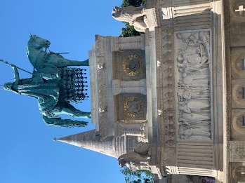
Our original short layovers in Dubai and Singapore, became Sydney to Singapore, to Bangkok to Vienna to Budapest with long delays of at least 7 hours at each airport taking over 2 days to arrive at Budapest! Luckily our return trip was reasonable, and no luggage was lost.
Meeting with our youngest daughter Frances, her husband and our grandchildren, 2 boys and 2 girls between the ages of 4 & 11 we were greeted at the Budapest airport by my 87 year old uncle and his wife who have both lived in Budapest all their lives ( a very fit couple who walk 6-12km most days). It was lovely to see them, and as usual they were very kind taking us to an AIRBNB in the heart of the city. A beautiful old building built around the 1880’s with thick walls, nice stairway, high ceilings, double glazed windows and 8 bedrooms.
Our trip was geared towards the children having fun and learning the culture, they enjoyed every bit of it and at the end surprisingly wanted to learn to speak Hungarian.
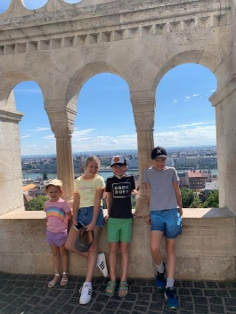
First, we went to ‘‘Varos Liget’’ City Park which was huge and contained numerous and different sophisticated climbing equipment, swings and the usual play sets. There are many Water parks in the city with lots of water slides and wave pools. Almost every city in Hungary has hot artesian water, which I tried but did not gain any improvements with my back problems.
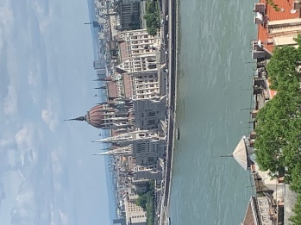
Some famous sights we went on to see in Budapest included the Fisherman’s Bastons, nearby is a statue of St Steven the first King of Hungary who forced the people to become catholic or beheaded them! Pictured is the entrance to the Castle Hill area with magnificent views of the Dunabe and Pest side and the stunning ornate parliament house. Adjacent is the beautiful St Matthias church where the children enjoyed climbing the high towers the most.
My daughter was brave enough to drive us in a big van on the right side of the road at 130km/h, arriving at lake Balaton the largest lake in Europe with 197km of shoreline. It is composed of beaches, resorts, water bikes and canoes for the children. Our resort at Tapolca near Balaton also had water slides, play centers and a nearby cave with a river at the bottom where we had a 20-minute boat ride. Also nearby was an old castle called SUMEG with horse rides and entertainment for the children.
Next, we travelled to Szeged where Alex was born. Szeged is the third largest city in Hungary and very picturesque as it was rebuilt in neo-gothic style after the great flood in 1879. There are lots of squares, botanic gardens and the fantastic MORA FERNC museum. Szeged is also home to the longest waterslide in Europe. The countryside is very scenic but is very dry this year. Szeged also has a famous university, including the famous medical faculty, and is known for the best strudels in the world baking them fresh on the spot including cherry, cottage cheese and poppyseed.
From Szeged we drove to the far north west to GYOR where I lived. To my great surprise the old town is very scenic and has a beautiful cathedral. This was all new to me as I have no memory of this as an 8-year-old.
Generally, everyone seemed to be happy and undisturbed by the Ukrainian war. Hungary gladly accepted a few hundred thousand Ukrainian refugees, the main concern is the inflation, food prices and heating via gas from Russia being cut.
Hungary has always been a great support of Ukrainian Sovereignty as well as its integration into the west but is obsessed that Ukrainians obstructed all minority languages such as Hungarian, Polish and Russian. Since the Russian invasion of Ukraine, the Hungarian prime minister Victor Orban (who many think is becoming a bit of dictator) has tried not to be associated with Putin’s regime. Previously Hungary had a pretty friendly relationship with Russia.
Anna Vass

