2010 Changeover photo gallery

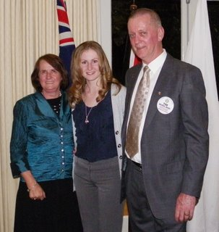
Alison and PP Tim Bowland lead our farewell to Fabienne
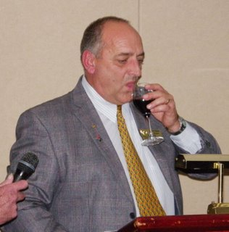
AG Peter Visser Proposes the toast to RI
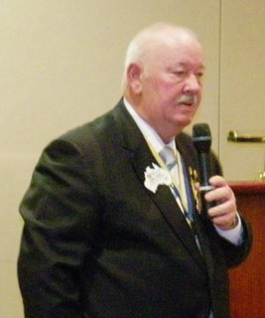
PDG Larry responds
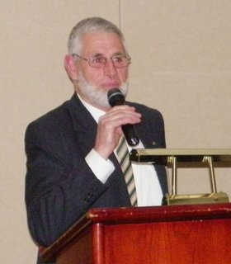
PP Brian Furrer proposes the toast to our Partners
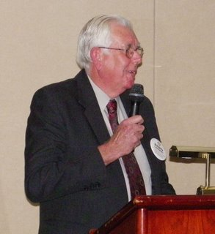
PP Barry Lambert is our masterly MC
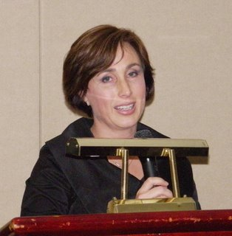
Margaret and Graham's Daughter Cassandra deputising for Margaret who was not well
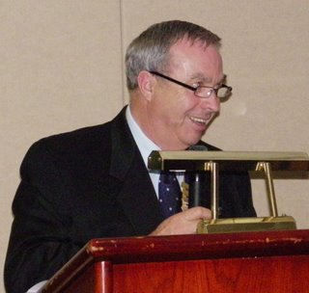
Soon to be PP Graham is all smiles
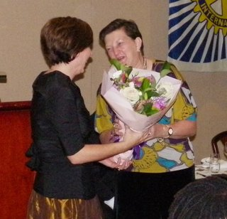
Cassandra presents flowers to Judy on behalf of her Mum
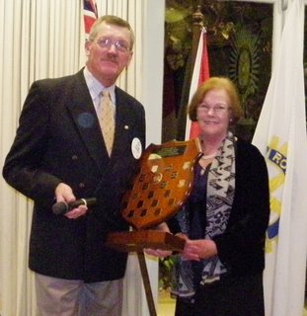
Rob Hamer presented the Allyn Day Award by Bev Day
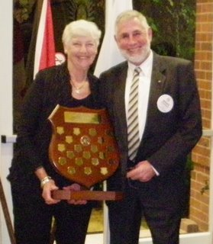
Brian Furrer is presented the Trevor Turner Award by Ann Turner
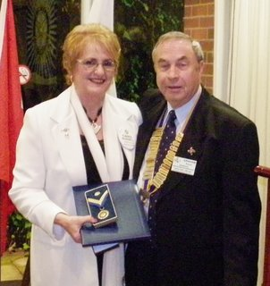
PHF Awardee Carol Russell receiving her Award from President Graham
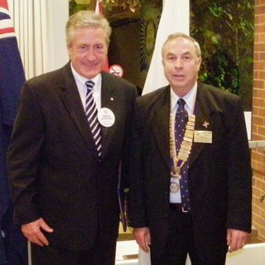
PHF Awardee Colin McGowan receiving his award from President Graham
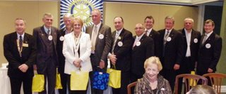
The outgoing Board
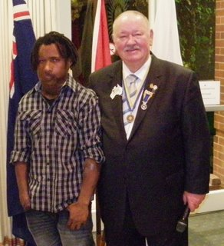
Wesley Koni pictured with PDG Larry following his inspiring speach
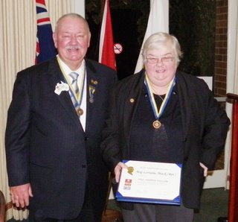
PDG Larry presenting a PHF to Lorainne Mack
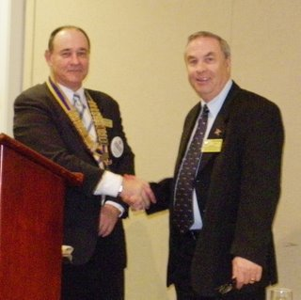
Graham Hands over to Graham
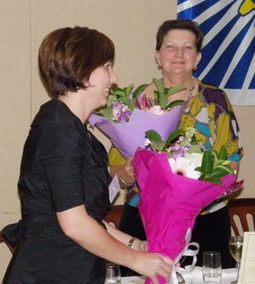
Cassandra and Judy exchanging flowers
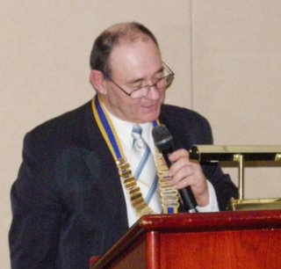
President Graham's 1st address
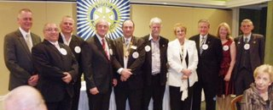
The incoming board
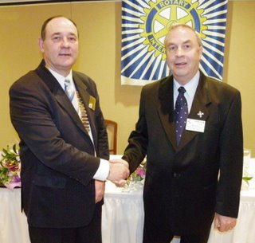
The happy pair
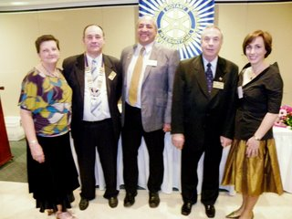
The official group
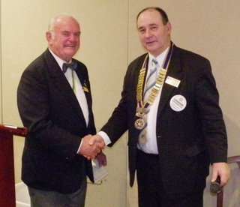
Congratulations for Graham and our Club from a representative of Graham's Dad's Club in Wagga Wagga

