2009 Changeover photo gallery

Club changeover function held at Pennant Hills Golf Club
on Friday 26 June 2009 where outgoing President Tim Bowland
handed over the reins to incoming President Graham Evans
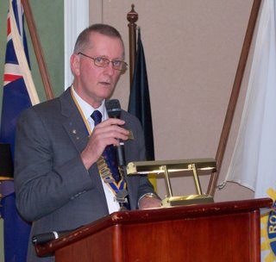
Outgoing President Tim Bowland welcoming all our guests
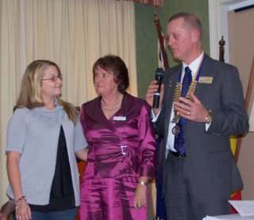
President Tim and wife Alison say farewell to exchange student
Héloïse Hansen who is returning to Belguim in two weeks
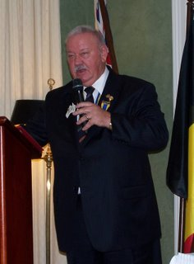
PDG Larry Jacka proposing the toast to Rotary International
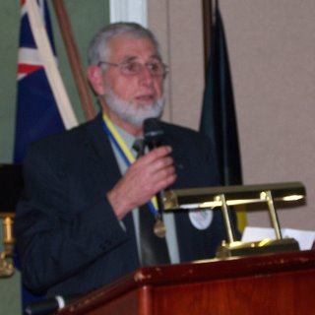
PP Brian Furrer proposing the toast to our Partners
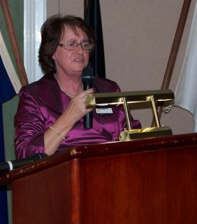
Alison Bowland responding on behalf of our Partners
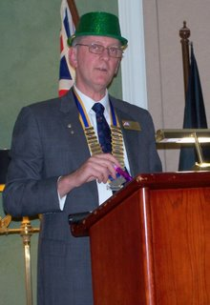
Outgoing President Tim Bowland partying it up during his year-in-review address
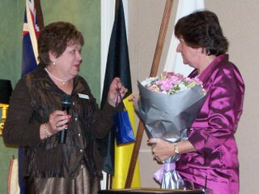
Margaret Evans and Alison Bowland exchange flowers
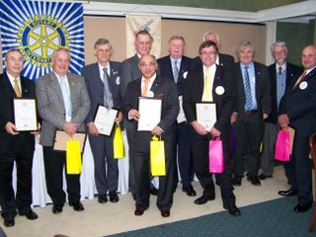
The outgoing team
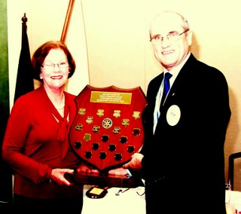
Bev Day presenting the Allyn Day Award to PP Dick Bushell
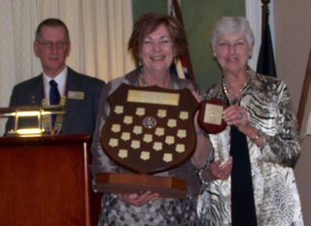
Ann Turner presenting the Trevor Turner Award to Prue Daras
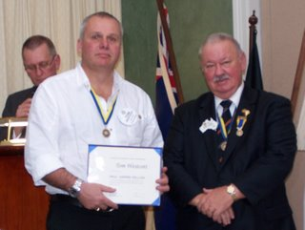
PDG Larry Jacka presenting a Paul Harris Fellowship to Tom Westcott
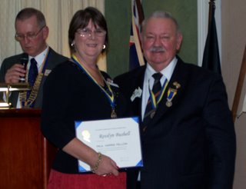
PDG Larry Jacka presenting a Paul Harris Fellowship to Rosslyn Bushell
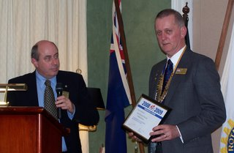
ADG Roland Crook presenting a Presidential Club Citation to
outgoing President Tim Bowland
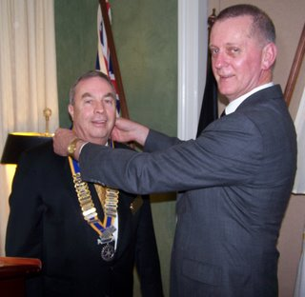
Outgoing President Tim Bowland placing the Collar of office
on Incoming President Graham Evans
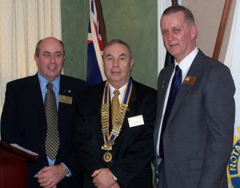
ADG Roland Crook, President Graham Evans and
Past President Tim Bowland
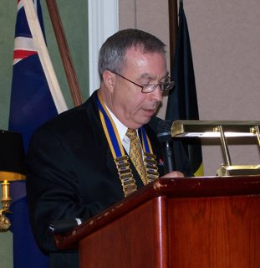
President Graham Evans introducing his team
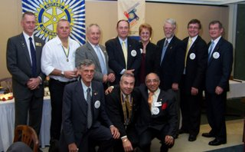
The incoming team
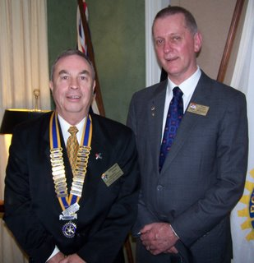
President Graham Evans and Past President Tim Bowland
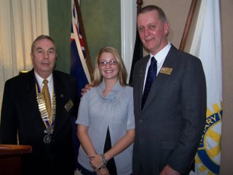
Farewell Héloïse Hansen

