2008 Changeover photo gallery
The 2008 Changeover was held at Pennant Hills Golf Club where Outgoing President Barry Lambert handed over to Incoming President Tim Bowland
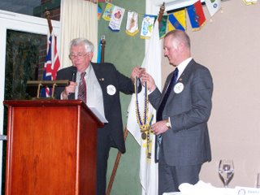
David and Jill Turnbull farewell Erica Jansakar
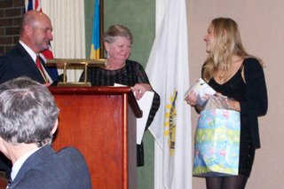
Club choristers Rob, Peter and Dick serenade Erika
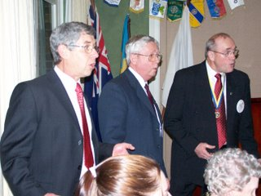
Outgoing President Barry delivers his final address as President
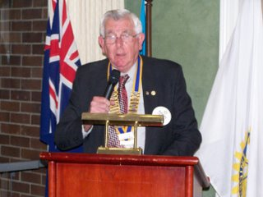
President Barry presents the Allyn Day Award to Bob Davison
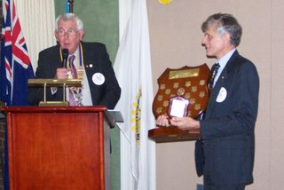
President Barry presenting Paul Harrs Fellowships to Olive and Jill Turnbull
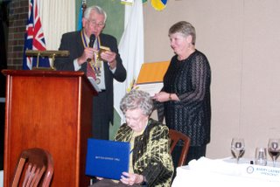

The outgoing Board
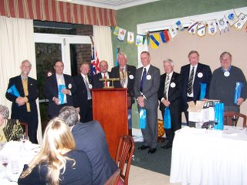
Incoming President Tim outlines his plans for the coming year
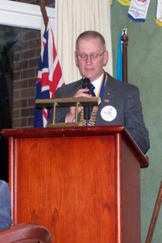

Charter President Trevor Turner attending his last Changeover
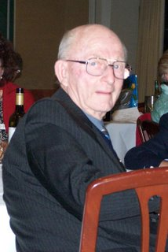
The incoming Board
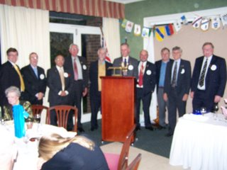
Helen and Lambert, Tm and Alison Bowland pictured with District Governor Tony Castely and his wife Sandra